Experiment No.: 02 Date: / /
1-Bit Adder and Subtractor
AIM: Design and realize:-
a. Half adder and verify its truth table.
b. Full adder and verify its truth table.
c. Half Subtractor and verify its truth table
d. Full Subtractor and verify its truth table.
EQUIPMENTS & COMPONENTS:
- Digital Trainer Board
- ICs – 7404, 7486, 7432, 7408
THEORY:
Adders are digital circuits that carry out addition of numbers. Adders are a key component of arithmetic logic unit. Adders can be constructed for most of the numerical representations like Binary Coded Decimal (BCD), Excess – 3, Gray code, Binary etc. out of these, binary addition is the most frequently performed task by most common adders. Apart from addition, adders are also used in certain digital applications like table index calculation, address decoding etc.
Binary addition is similar to that of decimal addition. Some basic binary additions are shown below.
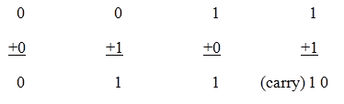
Figure1. Schematic representation of half adder

- Half Adder
Half adder is a combinational circuit that performs simple addition of two binary numbers. If we assume A and B as the two bits whose addition is to be performed, the block diagram and a truth table for half adder with A, B as inputs and Sum, Carry as outputs can be tabulated as follows.
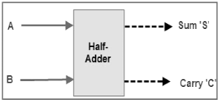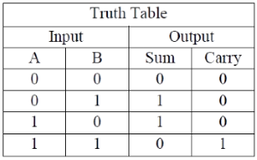
Figure2. Block diagram and truth table of half adder
The sum output of the binary addition carried out above is similar to that of an Ex-OR operation while the carry output is similar to that of an AND operation. The same can be verified with help of Karnaugh Map.
The truth table and K Map simplification and logic diagram for sum output is shown below.
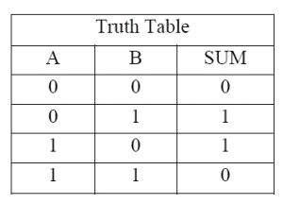 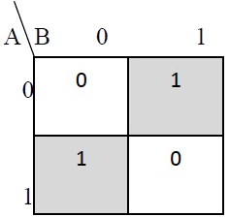 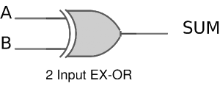
Figure3. Truth table, K Map simplification and Logic diagram for sum output of half adder
Sum = A B' + A' B
The truth table and K Map simplification and logic diagram for carry is shown below.
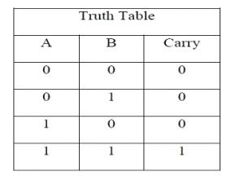 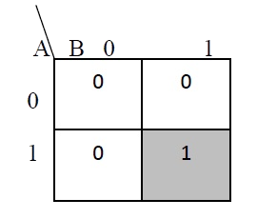 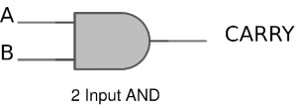
Figure4. Truth table, K Map simplification and Logic diagram for sum output of half adder
Carry = AB
If A and B are binary inputs to the half adder, then the logic function to calculate sum S is Ex – OR of A and B and logic function to calculate carry C is AND of A and B. Combining these two, the logical circuit to implement the combinational circuit of half adder is shown below.
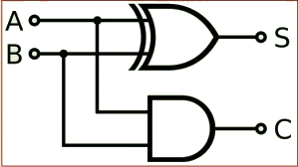
Figure5. Half Adder Logic Diagram
- Full Adder
Full adder is a digital circuit used to calculate the sum of three binary bits. Full adders are complex and difficult to implement when compared to half adders. Two of the three bits are same as before which are A, the augend bit and B, the addend bit. The additional third bit is carry bit from the previous stage and is called 'Carry' – in generally represented by CIN. It calculates the sum of three bits along with the carry. The output carry is called Carry – out and is represented by Carry OUT.
The block diagram of a full adder with A, B and CIN as inputs and S, Carry OUT as outputs is shown below.
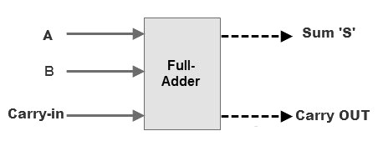 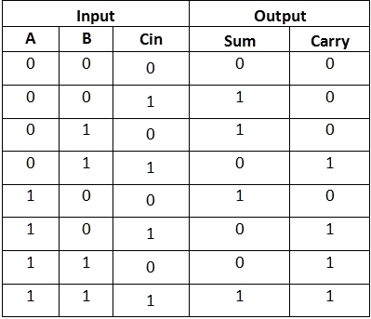
Figure 6. Full Adder Block Diagram and Truth Table

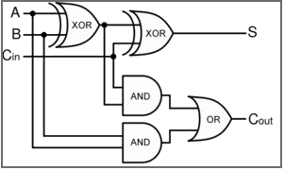
Figure7. Full Adder Logic Diagram
Based on the truth table, the Boolean functions for Sum (S) and Carry – out (COUT) can be derived using K – Map.
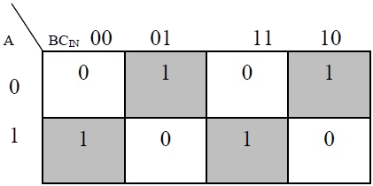
Figure8. The K-Map
Simplified equation for sum is S = A'B'Cin + A'BCin' + ABCin

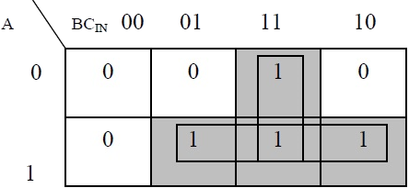
Figure9. The K-Map simplified equation for COUT is COUT = AB + ACIN + BCIN
In order to implement a combinational circuit for full adder, it is clear from the equations derived above, that we need four 3-input AND gates and one 4-input OR gates for Sum and three 2-input AND gates and one 3-input OR gate for Carry – out.

Subtractor:
Subtractor circuits take two binary numbers as input and subtract one binary number input from the other binary number input. Similar to adders, it gives out two outputs, difference and borrow (carry-in the case of Adder). There are two types of Subtractors.
- Half Subtractor
- Full Subtractor

- Half Subtractor
The half-Subtractor is a combinational circuit which is used to perform subtraction of two bits. It has two inputs, A (minuend) and B (subtrahend) and two outputs Difference and Borrow. The logic symbol and truth table are shown below.
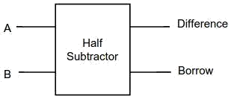
Figure-1: Logic Symbol of Half Subtractor
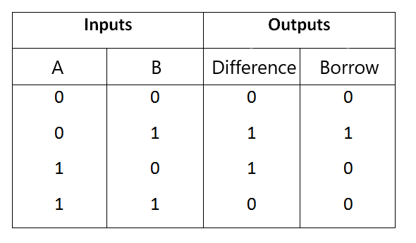
Figure-2: Truth Table of Half Subtractor

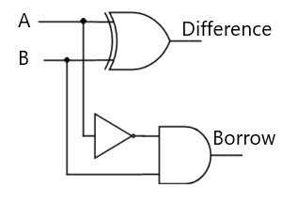
Figure-3: Circuit Diagram of Half Subtractor
From the above truth table we can find the Boolean expression.
Difference = A ⊕ B
Borrow = A' B
From the equation we can draw the half-Subtractor circuit as shown in the figure 3.
- Full Subtractor
A full Subtractor is a combinational circuit that performs subtraction involving three bits, namely A (minuend), B (subtrahend), and Bin (borrow-in) . It accepts three inputs: A (minuend), B (subtrahend) and a Bin (borrow bit) and it produces two outputs: D (difference) and Bout (borrow out). The logic symbol and truth table are shown below.
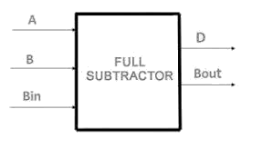
Figure-4: Logic Symbol of Full Subtractor
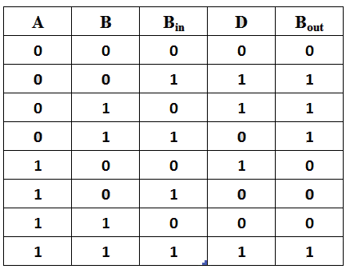
Figure-5:Truth Table of Full Subtractor
From the above truth table we can find the Boolean expression.
D = A ⊕ B ⊕ Bin
Bout = A' Bin + A' B + B Bin
From the equation we can draw the Full-Subtractor circuit as shown in the figure 6.
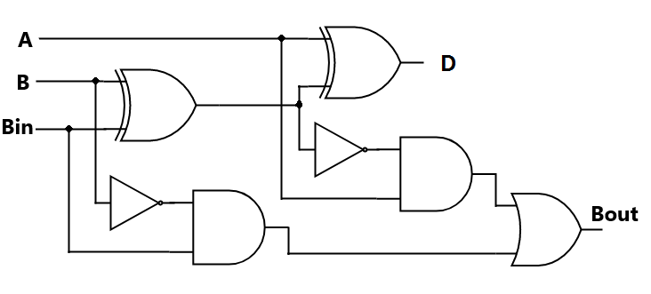
Figure-6: Circuit Diagram of Full Subtractor

PROCEDURE:
- Test the IC No 7486, 7404, 7432, and 7408.
- Place the ICs on the Bread Board/Trainer kit.
- Connect VCC and ground to respective pins of IC Trainer Kit.
- Connect the inputs to the input switches provided in the IC Trainer Kit.
- Connect the outputs to the switches of O/P LEDs,
- Do all the connections of ICs as per the pin configuration and circuits.
- Apply various combinations of inputs according to the truth table and observe condition of LEDs.
- Verify observed outputs each with the Truth tables of half adder, Full Adder, Half Subtractor and Full Subtractor.

CONCLUSIONS:

